Práctica 4: Clasificación multi-clase y redes neuronales
Esther Babon Arcauz

El primer paso ha sido implementar las funciones sigmoide, coste, gradiente y descenso de gradiente, teniendo en cuenta esta vez, que usamos como parámetro de entrada theta en vez de w y b.

Una vez declaradas estas funciones auxiliares, declare la función oneVsAll para entrenar a la vez los 10 clasificadores de regresión logística regularizada. Cada clasificador se entrena de manera independiente usando un bucle.

Después, he declarado la función predictOneVsAll, donde para cada entrada calcula la probabilidad de pertenecer a cada una de las 10 clases, devuelve la etiqueta de la clase de la que mayor probabilidad tiene de pertenecer. He utilizado la función argmax de numpy para vectorizar esta función.

He entrenado el modelo usando la función oneVsAll y he sacado las predicciones usando la función predictOneVsAll, la exactitud del modelo es del 93’22%. El enunciado comenta que la exactitud debe estar sobre el 95%, me parece un valor suficientemente bueno, seguramente difiera en los valores de los parámetros de la tasa de aprendizaje, el número de iteraciones y/o lambda.

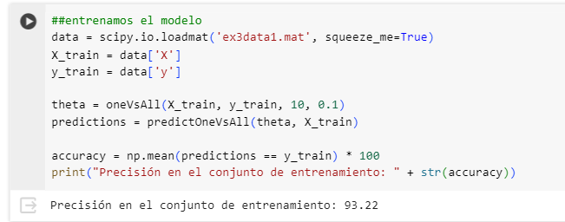

Con valores alpha = 0.3, numIter = 10000, lambda=0.1, la exactitud es del 94’19%

Para la segunda parte de la práctica, tenía que representar las predicciones de un modelo de redes neuronales, teniendo ya los pesos de las dos capas de la red neuronal.

He implementado la función predict, que tiene como entrada los pesos de las capas de la red neuronal y el conjunto de datos a entrenar. Calculando de manera feedforward hθ(x(i)) para cada ejemplo y devolviendo la prediccion. Para hacerlo de manera vectorizada he añadido una columna de 1s antes de hacer el cálculo.

Finalmente, la exactitud del modelo es del 97’52% que está dentro del valor previsto.

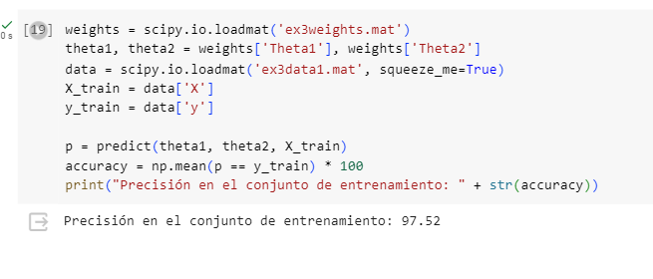

import numpy as np
from matplotlib import pyplot
import scipy

def displayData(X, example_width=None, figsize=(10, 10)):
"""
Displays 2D data stored in X in a nice grid.
"""
# Compute rows, cols
if X.ndim == 2:
m, n = X.shape
elif X.ndim == 1:
n = X.size
m = 1
X = X[None] # Promote to a 2 dimensional array
else:
raise IndexError('Input X should be 1 or 2 dimensional.')

example_width = example_width or int(np.round(np.sqrt(n)))
example_height = n / example_width

# Compute number of items to display
display_rows = int(np.floor(np.sqrt(m)))
display_cols = int(np.ceil(m / display_rows))

fig, ax_array = pyplot.subplots(
display_rows, display_cols, figsize=figsize)
fig.subplots_adjust(wspace=0.025, hspace=0.025)

ax_array = [ax_array] if m == 1 else ax_array.ravel()

for i, ax in enumerate(ax_array):
ax.imshow(X[i].reshape(example_width, example_width, order='F'),
cmap='Greys', extent=[0, 1, 0, 1])
ax.axis('off')

rand_indices = np.random.choice(X.shape[0], 100, replace=False)
displayData(X[rand_indices, :])

##Definimos funciones auxiliares que vamos a necesitar para entrenar nuestro modelo onevsall
def sigmoid(z):
return 1 / (1 + np.exp(-z))

def cost_function_reg(theta, X, y, lambda_):
h = sigmoid(np.dot(X, theta))
reg_term = (lambda_ / (2 * len(y))) * np.sum(theta[1:] ** 2)
J = (1 / len(y)) * (-np.dot(y, np.log(h)) - np.dot((1 - y), np.log(1 - h))) + reg_term
return J

def gradient_reg(theta, X, y, lambda_):
h = sigmoid(np.dot(X, theta))
grad = (1 / len(y)) * np.dot((h - y), X)
reg_term = (lambda_ / len(y)) * theta
reg_term[0] = 0
grad += reg_term
return grad

def gradient_descent(X, y, theta, alpha, num_iters, lambda_):
J_history = []
for _ in range(num_iters):
theta -= alpha * gradient_reg(theta, X, y, lambda_)
J_history.append(cost_function_reg(theta, X, y, lambda_))

return theta, J_history

def oneVsAll(X, y, n_labels, lambda_):
"""
Trains n_labels logistic regression classifiers and returns
each of these classifiers in a matrix all_theta, where the i-th
row of all_theta corresponds to the classifier for label i.

Parameters
----------
X : array_like
The input dataset of shape (m x n). m is the number of
data points, and n is the number of features.

y : array_like
The data labels. A vector of shape (m, ).

n_labels : int
Number of possible labels.

lambda_ : float
The logistic regularization parameter.

Returns
-------
all_theta : array_like
The trained parameters for logistic regression for each class.
This is a matrix of shape (K x n+1) where K is number of classes
(ie. `n_labels`) and n is number of features without the bias.
"""
m, n = np.shape(X)
alpha = 0.3
num_iters = 100000
all_theta = np.zeros((n_labels, n + 1))
X = np.concatenate([np.ones((m, 1)), X], axis=1)

for c in range(n_labels):
initial_theta = np.zeros(n + 1)
y_label = (y == c).astype(int)
theta, _ = gradient_descent(X, y_label, initial_theta, alpha, num_iters, lambda_)
all_theta[c, :] = theta

return all_theta

def predictOneVsAll(all_theta, X):
"""
Return a vector of predictions for each example in the matrix X.
Note that X contains the examples in rows. all_theta is a matrix where
the i-th row is a trained logistic regression theta vector for the
i-th class. You should set p to a vector of values from 0..K-1
(e.g., p = [0, 2, 0, 1] predicts classes 0, 2, 0, 1 for 4 examples) .

Parameters
----------
all_theta : array_like
The trained parameters for logistic regression for each class.
This is a matrix of shape (K x n+1) where K is number of classes
and n is number of features without the bias.

X : array_like
Data points to predict their labels. This is a matrix of shape
(m x n) where m is number of data points to predict, and n is number
of features without the bias term. Note we add the bias term for X in
this function.

Returns
-------
p : array_like
The predictions for each data point in X. This is a vector of shape (m, ).
"""
m = X.shape[0]
X_bias = np.hstack([np.ones((m, 1)), X])
prob = sigmoid(np.dot(X_bias, all_theta.T))
p = np.argmax(prob, axis=1)

return p

##entrenamos el modelo
data = scipy.io.loadmat('ex3data1.mat', squeeze_me=True)
X_train = data['X']
y_train = data['y']

theta = oneVsAll(X_train, y_train, 10, 0.1)
predictions = predictOneVsAll(theta, X_train)

accuracy = np.mean(predictions == y_train) * 100
print("Precisión en el conjunto de entrenamiento: " + str(accuracy))

def predict(theta1, theta2, X):
"""
Predict the label of an input given a trained neural network.

Parameters
----------
theta1 : array_like
Weights for the first layer in the neural network.
It has shape (2nd hidden layer size x input size).

theta2: array_like
Weights for the second layer in the neural network.
It has shape (output layer size x 2nd hidden layer size).

X : array_like
The image inputs having shape (number of examples x image dimensions).

Returns
-------
p : array_like
Predictions vector containing the predicted label for each example.
It has a length equal to the number of examples.
"""
m = X.shape[0]
X_bias = np.hstack([np.ones((m, 1)), X])

z2 = np.dot(X_bias, theta1.T)
a2 = sigmoid(z2)
a2_bias = np.hstack([np.ones((m, 1)), a2])

z3 = np.dot(a2_bias, theta2.T)
a3 = sigmoid(z3)

p = np.argmax(a3, axis=1)

return p

weights = scipy.io.loadmat('ex3weights.mat')
theta1, theta2 = weights['Theta1'], weights['Theta2']
data = scipy.io.loadmat('ex3data1.mat', squeeze_me=True)
X_train = data['X']
y_train = data['y']

p = predict(theta1, theta2, X_train)
accuracy = np.mean(p == y_train) * 100
print("Precisión en el conjunto de entrenamiento: " + str(accuracy))

